Project Design Phase-II
Technology Stack (Architecture & Stack)

Date | 29 September 2026
Team ID | UNM111DJMRP
Project Name | AI FitTrack – AI-Powered Fitness Management and Recommendation System
Maximum Marks

Technical Architecture:
The Deliverable shall include the architectural diagram as below and the information as per the table1 & table 2
AI FitTrack – Technical Architecture
Reference: AI FitTrack Technical Documentation – Sections 5, 6, 14 and 17 (source: server/ and client/).
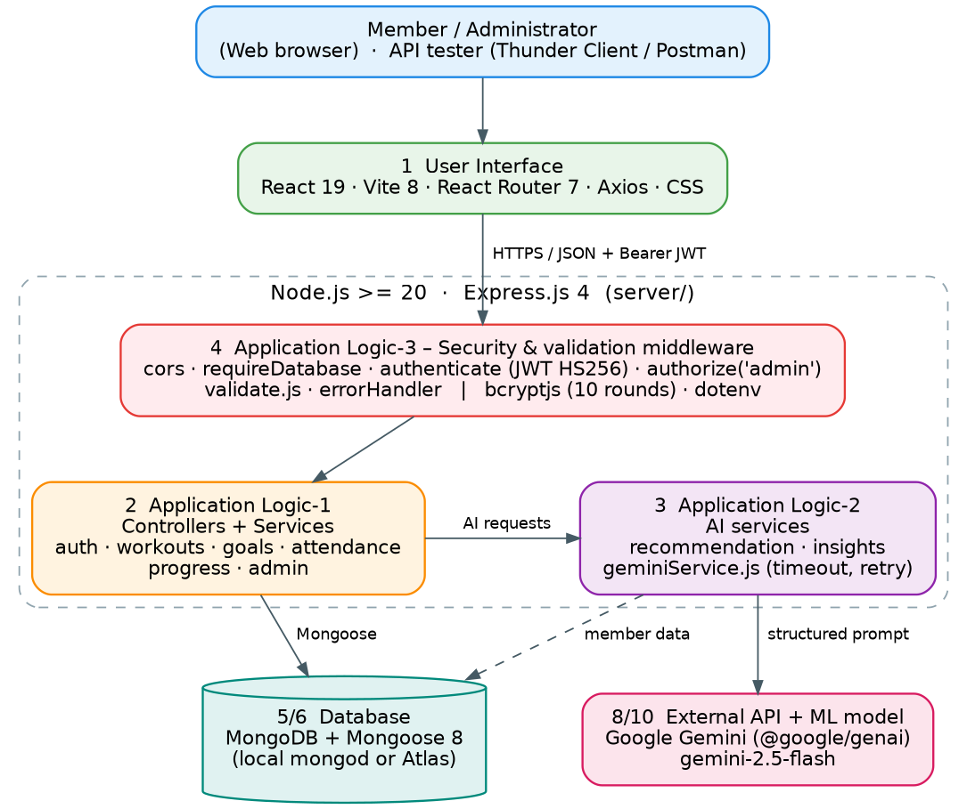
Figure 1: AI FitTrack technical architecture – React client, Express API with security middleware, application and AI logic, MongoDB and Google Gemini. Numbers refer to the rows of Table-1.
Table-1 : Components & Technologies:
S.No | Component | Description | Technology
 | User Interface | Web UI (React single-page app) for members and administrators: login, dashboard, workouts, goals, attendance, progress, AI pages and admin pages | React 19, React Router 7, Vite 8, Axios, hand-written CSS
 | Application Logic-1 | Core business logic: authentication, workouts, goals, attendance, progress analytics and admin aggregations (routes → controllers → services) | Node.js (≥ 20), Express.js 4
 | Application Logic-2 | AI logic: builds structured prompts from the member's data, calls Gemini with timeout and retry, validates the JSON reply | @google/genai SDK, geminiService.js, recommendationService.js, insightsService.js
 | Application Logic-3 | Security and validation middleware: JWT authentication, role authorization, declarative request validation, database guard, centralized error handling | jsonwebtoken (HS256), bcryptjs, custom validate.js, errorMiddleware
 | Database | NoSQL document database with collections User, Workout, FitnessGoal, Attendance; indexes incl. unique partial index for open visits | MongoDB with Mongoose 8
 | Cloud Database | Optional managed database service through a mongodb+srv:// connection string | MongoDB Atlas
 | File Storage | Not required – the application has no file upload; all data is stored in MongoDB | Not applicable
 | External API-1 | Generates AI workout recommendations and AI fitness insights | Google Gemini API (default model gemini-2.5-flash)
 | External API-2 | Not used – Gemini is the only external API | Not applicable
 | Machine Learning Model | Pre-trained generative LLM used through prompt engineering (system instruction + JSON schema); no custom-trained model | Gemini 2.5 Flash
 | Infrastructure (Server / Cloud) | Application deployment on local system / cloud  Local server configuration: Node.js ≥ 20, API on port 5000, Vite client on port 5173, local mongod or Atlas; Windows / macOS / Linux, 8 GB RAM  Cloud server configuration: any Node.js ≥ 20 host with MongoDB Atlas; set MONGO_URI, JWT_SECRET, GEMINI_API_KEY and CLIENT_ORIGIN | Local development (VS Code, nodemon); cloud host optional

Table-2: Application Characteristics:
S.No | Characteristics | Description | Technology
 | Open-Source Frameworks | Open-source frameworks and libraries used across client and server | Express.js, React, Vite, React Router, Mongoose, Axios, cors, dotenv, nodemon
 | Security Implementations | Password hashing, JWT with pinned algorithm, role-based access, ownership checks, request validation and field whitelisting, regex escaping, CORS allow-list, secrets in environment variables, no personal identifiers sent to the AI | bcryptjs (10 rounds), jsonwebtoken (HS256), authorize('admin'), validate.js, dotenv
 | Scalable Architecture | Layered, modular MVC-style backend (routes, controllers, services, models) with stateless JWT authentication; AI provider isolated in one service | Node.js / Express, MongoDB / Atlas
 | Availability | Public health endpoint, fail-fast 503 when the database is down, optional managed MongoDB Atlas, several stateless API instances possible, AI failures do not affect other features | /api/health, requireDatabase middleware, MongoDB Atlas
 | Performance | Pagination with capped limits, compound index on workouts, progress computed per member, Gemini timeout (30 s) and bounded retries (3 attempts), no AI call when there is no data | MongoDB indexes, pagination utility, AbortController timeout

References:
https://c4model.com/
https://developer.ibm.com/patterns/online-order-processing-system-during-pandemic/
https://www.ibm.com/cloud/architecture
https://aws.amazon.com/architecture
https://medium.com/the-internal-startup/how-to-draw-useful-technical-architecture-diagrams-2d20c9fda90d

